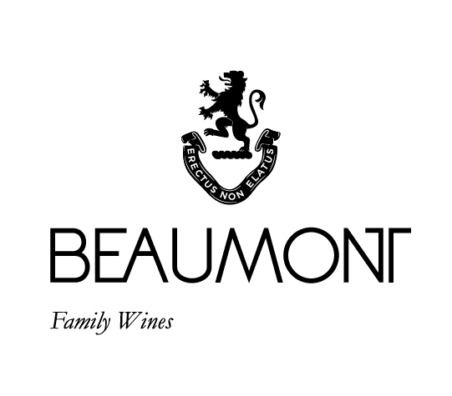

CHENIN BLANC | 2022

Our Chenin Blanc was made from 100% Beaumont, Bot River fruit. This is fruit filled unwooded Chenin Blanc. The vintage produced plenty grapes with good concentration following a beautiful and healthy growing season. It is a delicious example of cooler climate Chenin Blanc fermented in concrete and stainless-steel tanks using a combination of cultured and natural yeasts. Matured after fermentation on the lees to add some extra weight and complexity to the wine.

FOOD PAIRING | Great with seafood, especially shellfish and spicy Thai and Indian curries.
PACKAGING | 6 x 750 ml in screw cap
BARCODE bottle 6009077000139 box 16009077000136

RATINGS & REVIEWS | Since our first vintage in 1996 we have committed to making a style of Chenin that captures the purity of the grape. Previous vintages have been regular 4 star wines in Platter.

VINEYARD
AGE

Ranging between 3 and 48 yrs

CULTIVAR

Chenin Blanc

BOTTLES
PRODUCED

79930
bottles

pH

3.25

RS

5.4g/L

TA

6.5g/L

ALC

12.34%

BALLING AT HARVEST

19.5° - 23.5°
Balling

YIELD

6 – 8
tons / ha

APPELATION

Bot River
Walker Bay

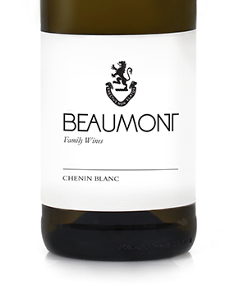
WINE MAKER | Sebastian Beaumont.

VINTAGE CONDITIONS | The 2022 vintage produced another year of great healthy fruit. Good cold winter with lots of rain followed through to the summer. Cool conditions persisted right through the ripening time allowing the fruit to develop lots of intensity on the vine.

VINIFICATION | Early picking to preserve freshness, and balance in the wine. Our new press produced gave us very clean juice and I think it has had a very positive effect on this vintage. Long slow fermentation.

MATURATION | Average of 4 months on gross lees in tank.

AGEING POTENTIAL | 3 - 5 years.

