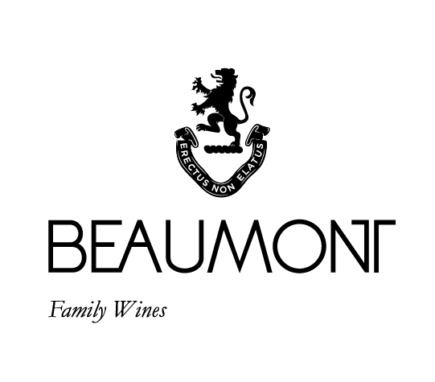

ARIANE | 2017

Beaumont Family Wines have been making this classic Bordeaux style blend named after Ariane Beaumont. The first vintage produced was in 1998.
Depending on the vintage the blend is either Merlot or Cabernet Sauvignon driven. It also always has some Cabernet Franc for perfume and freshness. The 2017 Ariane is going to prove to be one of our great vintages. This is a Cabernet Sauvignon driven vintage with all 4 of the other classic Bordeaux varietals contributing to the blend.

FOOD PAIRING | Bordeaux style blends are always best suited to classic red meat dishes. But let this wine mature and you will be able to enjoy it on its own.
PACKAGING | 6 x 750 ml and Magnums

RATINGS & REVIEWS | A wine that over the years has raked in quite a few 4.5 star ratings in the platter wine guide.
But its best ratings have come from the followers of the wine who come back every year to get their allocation.

CULTIVAR

34% Cab Sauv, 33% Merlot,
11% Cab Franc, 11%Malbec & 11% Petit Verdot

pH

3.56

RS

1.8 g/L

TA

5.7g/L

ALC

13.33%

BALLING AT HARVEST

22.5° - 24°
Balling

VINEYARD
AGE
.

23 yrs

BOTTLES
PRODUCED

2644 x 750ml bottles

APPELATION

Bot River

YIELD

4
tons / ha

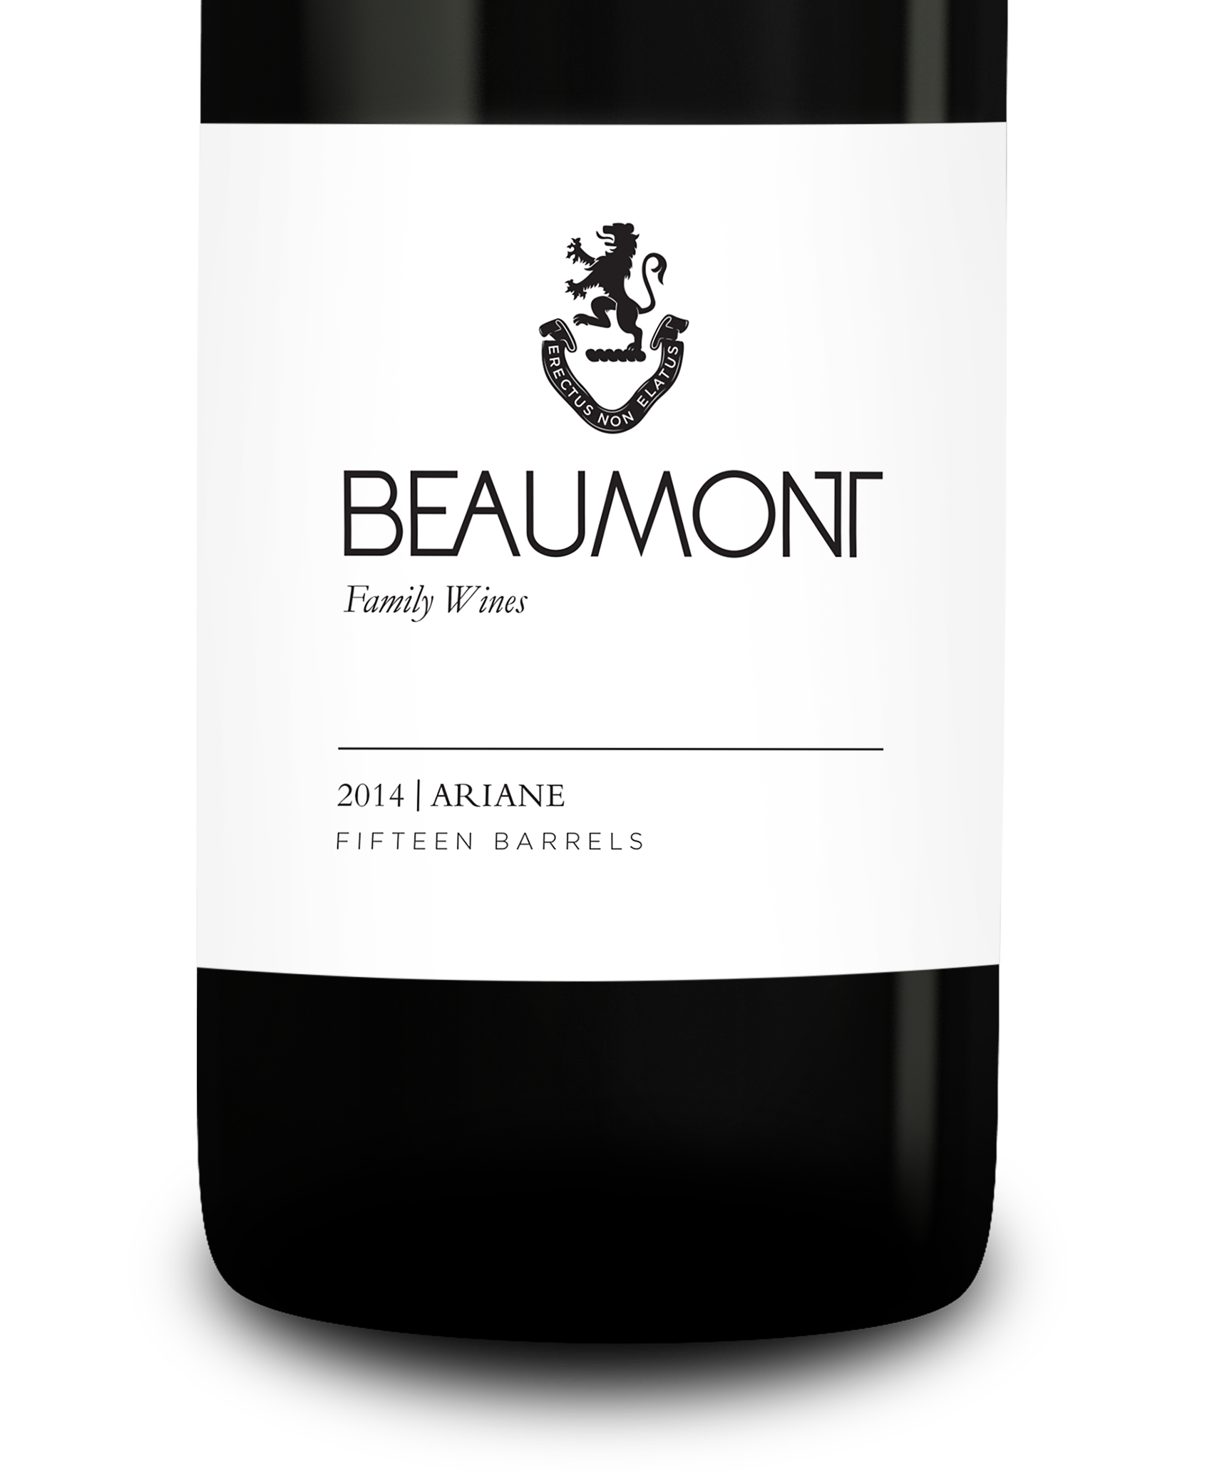
WINE MAKER | Sebastian Beaumont.

VINTAGE CONDITIONS | 2017 is a great vintage that produced wines with great intensity and balance. Dry conditions produced small yields of healthy fruit

VINIFICATION | After the grapes were cold soaked for 2 days till natural fermentation started. A warm ferment of 28-30 °C was allowed with 2 hourly punch downs in an open vat. Six days of fermentation with three weeks post maceration then pressed directly into barrel.

MATURATION | Maturation in French oak for 24 months.

AGEING POTENTIAL | 8 – 15 years.

