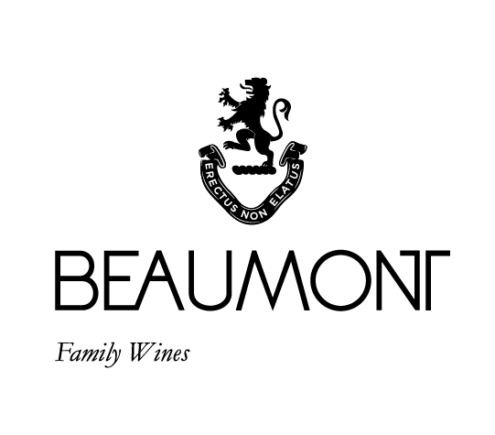

BEAUMONT PINOTAGE | 2018

Pinotage was the very first wine made at Beaumont wines and 26 years later we are still passionate Pinotage producers! 80% of the fruit comes from our 47 year old vines providing dryness and structure while the younger portion provides lovely vibrant fruit.
Our style reflects the cooler climate of the Bot River region. Harvested between mid February and mid March the grapes are then crushed into open concrete fermenters. Punched down 3-4 times per day until end of ferment, then pressed and taken to barrel for 18 months and then taken to tank for another 8 months. Fresh red berry fruit with a deliciously drinkable medium body and well integrated tannins.

FOOD PAIRING | Matches very well with bobotie, game and curries, spare ribs and pepper steak, or try snoek and grape jam.
PACKAGING | 6 x 750 ml
BARCODE bottle 6009077000160 box 16009077000167

RATINGS & REVIEWS | A consistent 4 star winner in Platter. This is still an elegant style of Pinotage with red berry and ripe fruit flavours with fine tannins and lovely fruit on the palate.
Jancis Robinson wrote that the 2011 vintage was one of the best Pinotages she had ever tasted.

VINEYARD
AGE
.
Old Vines: 47 yrs; Younger vines:
25 yrs

YIELD

Old vines:
1.5 to 3 tons/ha; Younger vines:
3 tons/ha

CULTIVAR

Pinotage

BOTTLES
PRODUCED

10257
bottles

pH

3.60

RS

1.4g/L

TA

5.8g/L

ALC

13.07%

BALLING AT HARVEST

23.5° - 25.5°
Balling

APPELATION

Bot River
Walker Bay

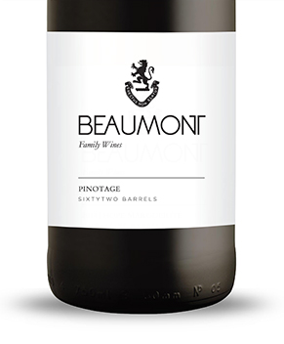
WINE MAKER | Sebastian Beaumont.

VINTAGE CONDITIONS | Earliest vintage ever produced very healthy fruit with great purtity and balance. Yield was half of a normal vintage.

VINIFICATION | Grapes were harvested and crushed directly into concrete tanks, followed by an immediate inoculation for a clean fermentation. Controlled temperatures allow for an optimum extraction period. Regular punch downs were done to assure good colour and tannin structure

MATURATION | 18 months in 100% French oak. 25% new oak.

AGEING POTENTIAL | 8 – 15 years

