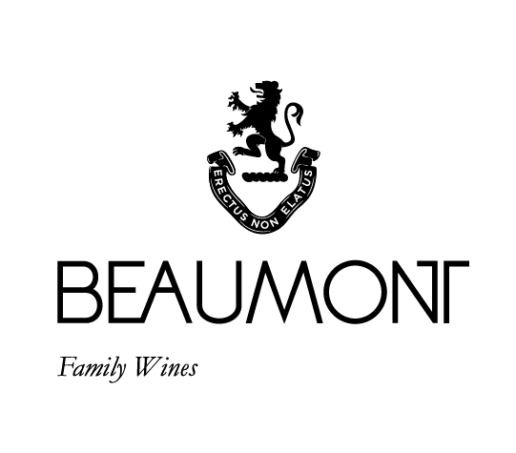

BEAUMONT Constable House Shiraz/Cabernet Sauvignon blend| 2018

The Constable House blend is now under the Beaumont name but still consists of the two varietals that work exceptionally well together namely Shiraz and Cab. Sauv.. The wine is named after the vineyard in front of the old Constables House on the farm. The ratio in the 2018 vintage is 76% Shiraz and 24% Cabernet Sauvignon.

RATINGS & REVIEWS | Three and a half stars in Platter for this vintage. This a wine that offers great value and always over delivers.

FOOD PAIRING | Spicy red meat, grilled pork or roasted lamb. Game such as springbok, ostrich, rabbit and venison, spices such as cumin and coriander enhanced the natural spice of this Shiraz.
PACKAGING | 6 x 750 ml

CULTIVAR

76% Shiraz,
24% Cab. Sauv.

BOTTLES
PRODUCED

18000 of the 750ml bottles;

APPELATION

Bot River

VINEYARD
AGE
.
10 – 44 yrs

YIELD

6 tons/ha

pH

3.67

RS

1.7g/L

TA

5.3g/L

ALC

12.46%

BALLING AT HARVEST

22° - 24°
Balling

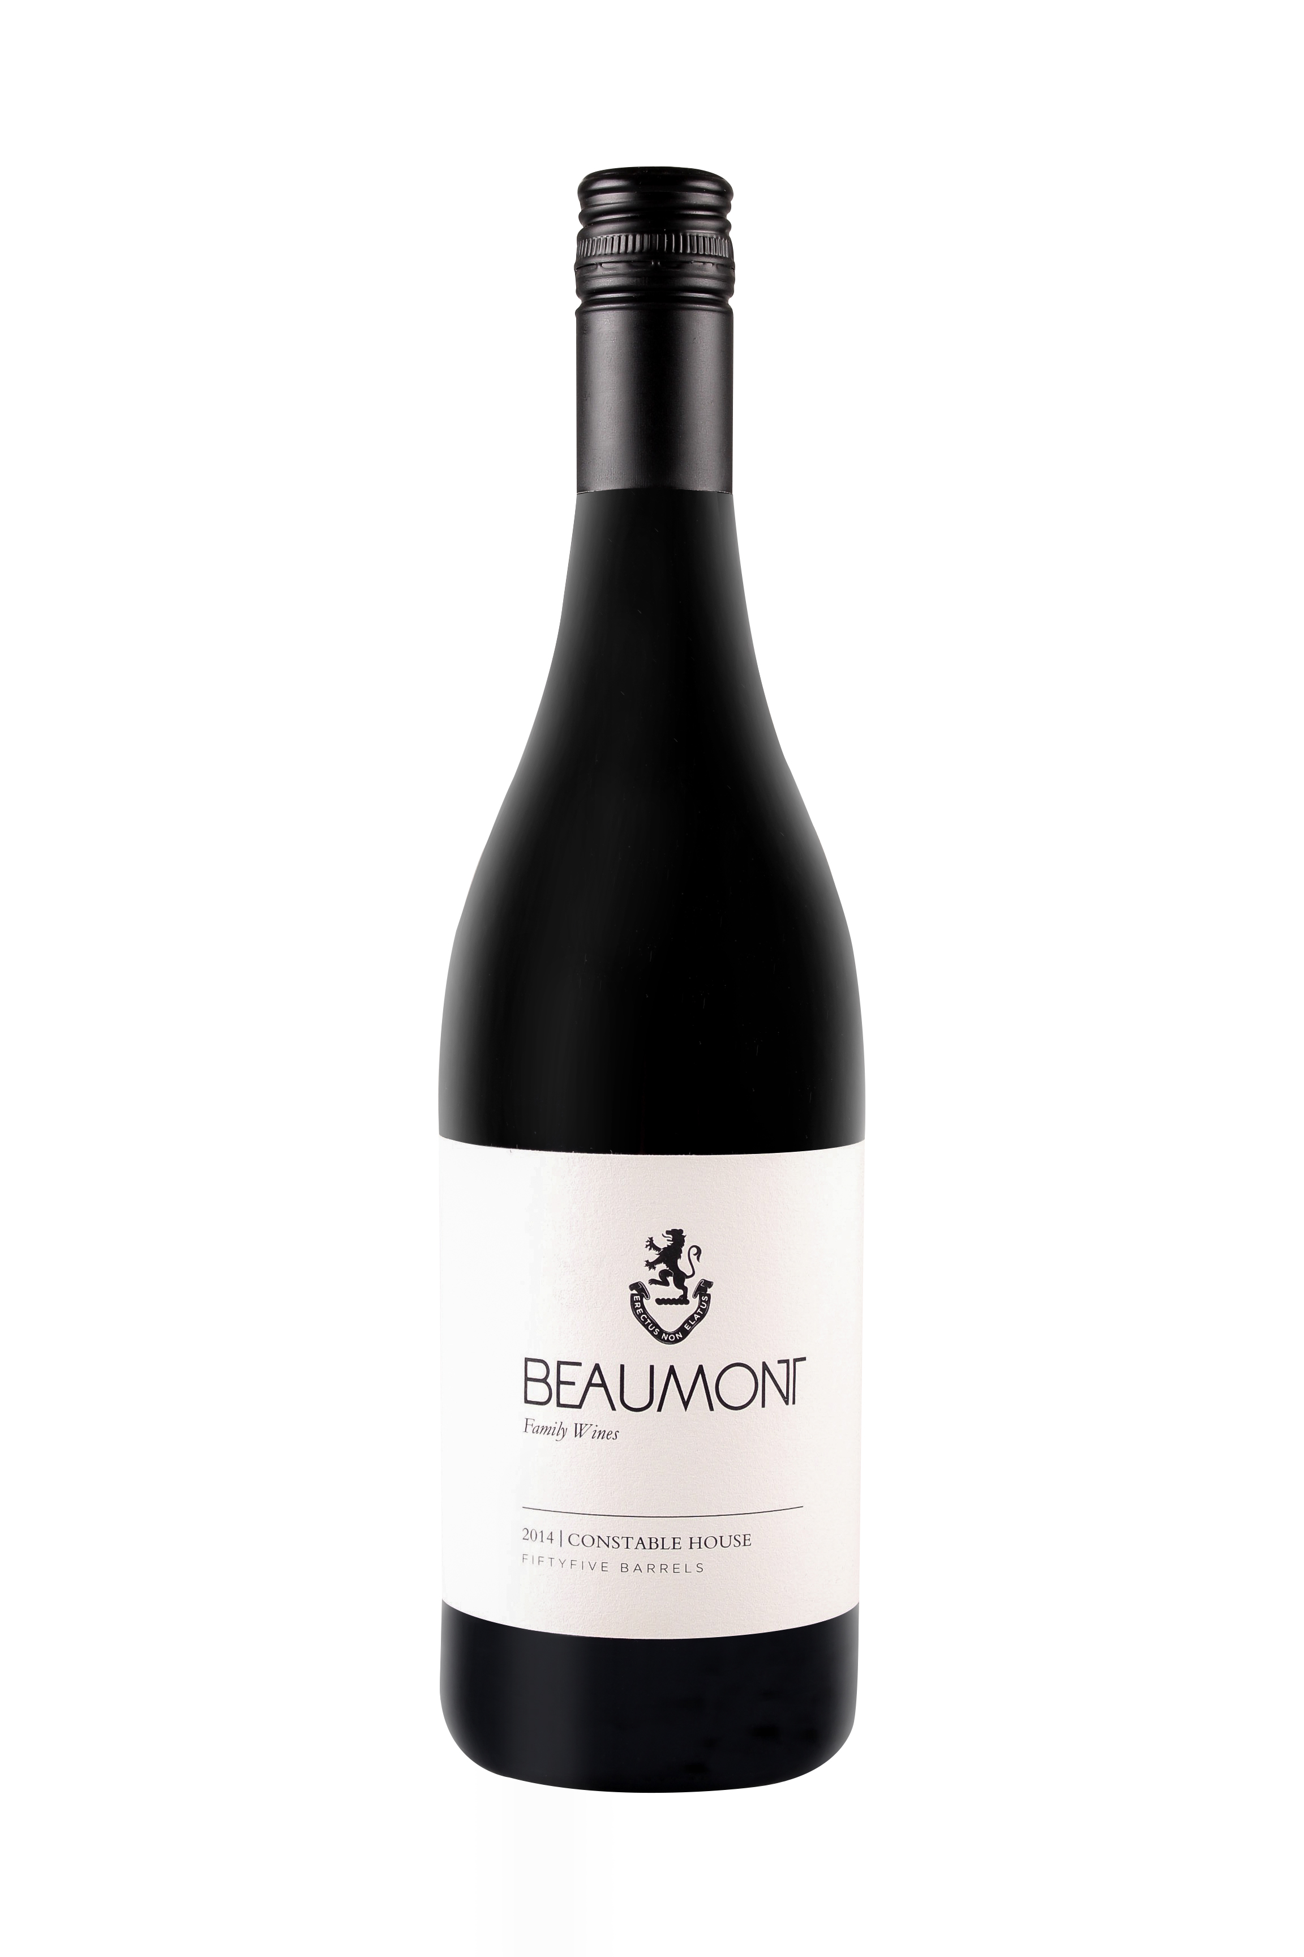
WINE MAKER | Sebastian Beaumont.

VINTAGE CONDITIONS | 2018 was a dry vintage that produced some very pure and delicate wines with wonderful fruit intensity and texture.

VINIFICATION | Picked and vinified separately. Using stalks during the fermentation to add to the complexity of the structure. Completely naturally fermented. Then pressed after a 12- 16 days on the skins and taken to a mixture of tank and barrel for malo lactic fermentation.

MATURATION | 14 months in older oak barrels.

AGEING POTENTIAL | 8 - 10 yars

