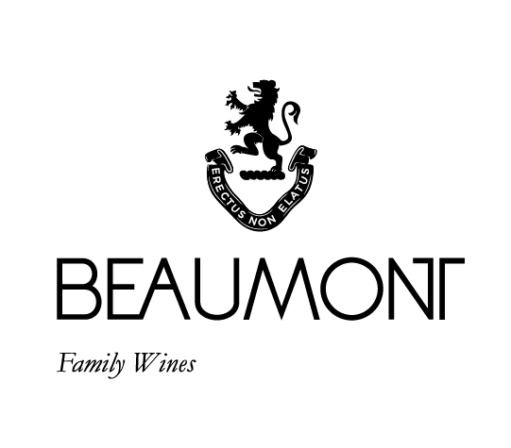

HOPE MARGUERITE | 2020

Named after Hope Marguerite Beaumont, a woman with character, elegance and a love for wine. We have produced this Chenin to reflect the pure character of the grape and the individual philosophy of Beaumont Family wines. Our first vintage of the Hope Marguerite was produced in 1997 and at that time there were only two other Chenin Blancs in South Africa produced in this style. Only fruit selected from our two oldest Chenin Blanc vineyards, planted in ‘74 and ‘78, are used for this wine. Barrel fermentation takes place in 400L French oak using only natural yeasts. Malo lactic fermentation occurs in certain vintages. The wine is kept on its gross lees for 10 months with regular batonage, giving it a richer and fuller palate.
The 2020 vintage is a classic expression of

RATINGS & REVIEWS | Our Flagship white wine has received nine Platter 5 star ratings in the past. Hope is seen as one of the benchmark barrel matured styles of Chenin in the country. It also received 95 points in Tim Atkin reviews and in the Wine Enthusiast.
FOOD PAIRING | Matches brilliantly with seafood especially scallops and any beautifully spicy Asian dish.
PACKAGING | 6 x 750 ml and 1.5 L
BARCODE bottle 6009077000191 box 16009077000198

BOTTLES
PRODUCED

18780 x 750ml & 2
Magnums

pH

3.09

RS

4.5g/L

TA

6.5g/L

ALC

12.26%

BALLING AT HARVEST

21° - 22.5°
Balling

YIELD

2.5 – 4
tons / ha

VINEYARD
AGE
.
43 – 47 yrs

APPELATION

Bot River
Walker Bay

CULTIVAR

Chenin Blanc

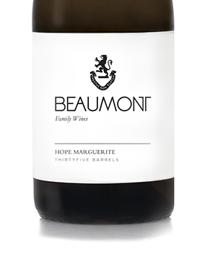
WINE MAKER | Sebastian Beaumont.

VINTAGE CONDITIONS | A normal wet cold winter allowed for good rest of the vines. Healthy ripening season produced perfect grapes resulting in fantastic juice.

VINIFICATION | Completely naturally fermented with minimum intervention in 400L French oak. No new oak in this vintage. Partial Malo lactic took place.

MATURATION | This wine remained on its gross lees for 10 months in 400L barrels with regular batonage. Final blending and bottling in early 2021.

AGEING POTENTIAL | Fresh, clean and powerful fruit which will develop beautifully over the next 5 – 15 years in bottle.

