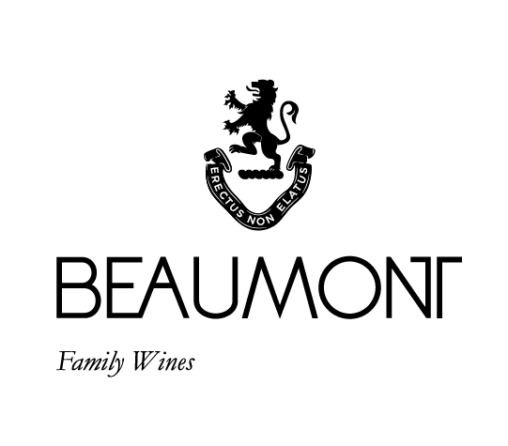

MOURVÈDRE | 2017

Beaumont Family Wines were the first winery in South Africa to bottle a single varietal Mourvèdre.
Originally the grape comes from Spain and France where it is mostly used to enhance blends. Mourvédre's dark, thick-skinned berries result in powerful spicy and sometimes gamey aromas in their youth.
This unique wine was made from a small parcel of Mourvèdre with a low crop yield of 2 -4 tons/ha. Grapes were harvested at full ripeness, cold soaked, fermented in concrete tanks with 30% whole bunch and allowed a post maceration of 3 weeks, thereafter it was pressed directly into 100% French oak barrels.

FOOD PAIRING | Spicy roasted red meat or game, grilled pork or calf’s liver, rich hearty dishes such as paella with chorizo and hot spices.
PACKAGING | 6 x 750 ml

RATINGS & REVIEWS | I always say that this is a wine for freaks! It is not everyone’s darling. But we have set a benchmark for the varietal in South Africa and show how it can consistently produce interesting wine.

pH

3.52

RS

2.4 g/L

TA

5.8g/L

ALC

13.89%

BALLING AT HARVEST

22.5° - 24°
Balling

YIELD

2- 4
tons / ha

VINEYARD
AGE
.
22 yrs

APPELATION

Bot River

CULTIVAR

Mourvedre

BOTTLES
PRODUCED

2220 and
25 x magnums

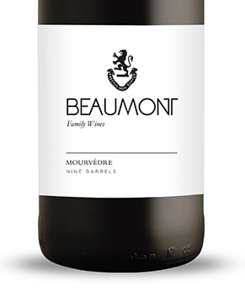
WINE MAKER | Sebastian Beaumont.

VINTAGE CONDITIONS | The 2017 vintage was amazing. Very dry season but despite this the wines have turned out beautifully. This is also the case with the Mourvedre.

VINIFICATION | After the grapes were cold soaked for 2 days till natural fermentation started. 30% of the bunches were added as whole bunches. A warm ferment of 28-30 °C was allowed with regular punch downs in an open vat. Six days of fermentation with three weeks post maceration then pressed directly into barrel.

MATURATION | Maturation in French oak for 24 months and 18 months in bottle.

AGEING POTENTIAL | 8 – 10 years.

